Step for RS Check Printing with S-Docs:

Steps 1-4 must be done after installing RSF and S-Docs. The remaining steps are completed by the customer.

1. Install S-Docs

2. Setup --> Create --> Object --> SDoc Template

Select the ‘Related To Type’ field

Add a new picklist value: rstkf__apcheck__c

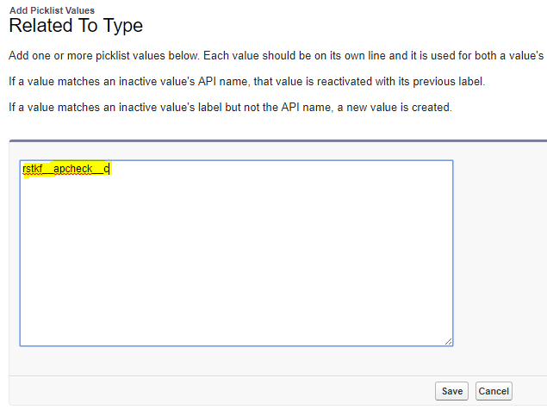

3. Create a new "SDoc Template" record

Select ‘S-Docs’ from the app dropdown

Select ‘S-Docs Templates’ tab

Select ‘New SDoc Template’ button

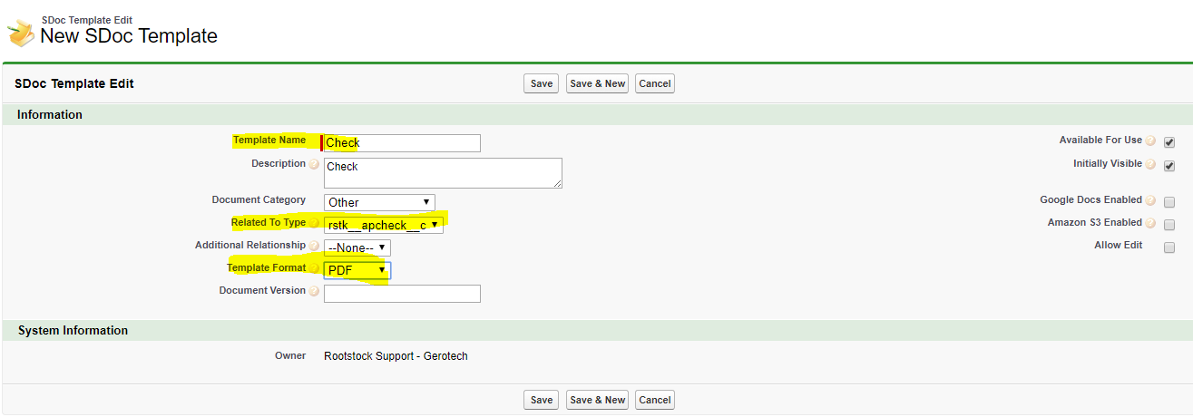

4. Click "Template Editor" button, click "Source" button, paste in code attached as "RS_APCHECK_TEMPLATE_RSTKF.txt". Things will look a little weird visually because of the merge fields.

THE REMAINING STEPS ARE COMPLETED BY THE CUSTOMER

5. Go to the AP Control record and change "3rd Party Package for Check Printing" to S-Docs and select out Check template we just created for the Default Check Print Template:

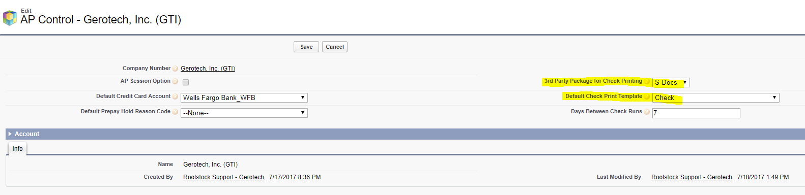

6. Go to RS Menu/Sitemap --> Accounts Payable --> Payment Selection, (select a record with Payment Type set to All or Check?)

7. Click "Review and Process Payments" button:

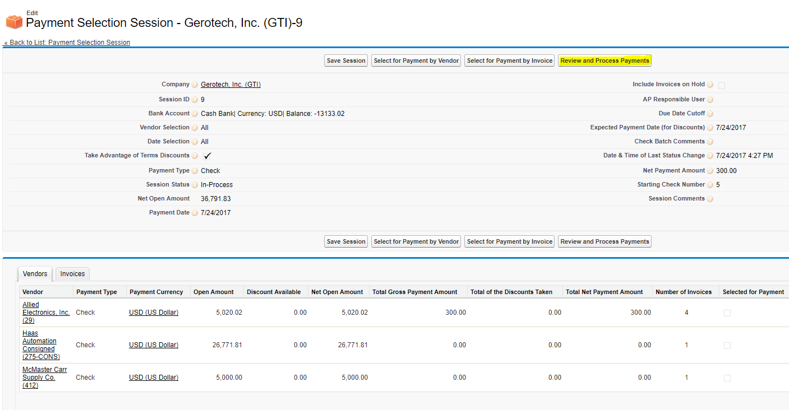

8. Click "Print Checks using (Check)" button:

